Nicholas Stanfill
Online Food Portal
Grand Canyon University | December 7, 2025
2025
Contents
Planning and Status 2
Test Plan, Test Cases, and Results 3
Item and Modification CRUD Test 3
Order CRUD Test 5
Password Hashing Service Test 6
Store Settings RU Test 6
User CRD Test 7
User Registration and Login Test 8

Video: https://youtu.be/cWncADcbafY
GitHub: https://github.com/NickNDY/Online-Food-Portal

Planning and Status
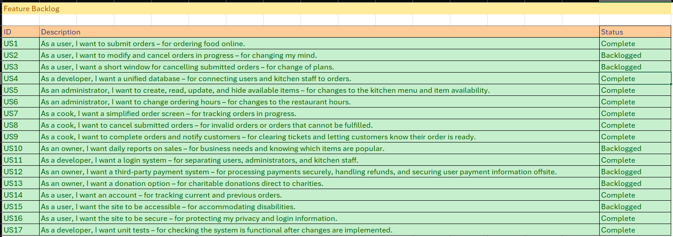
User Stories/ Feature Backlog
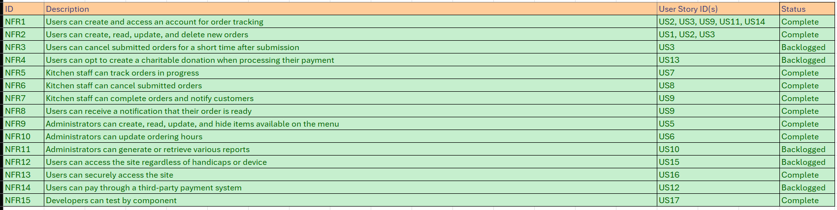
Non-Functional Requirements
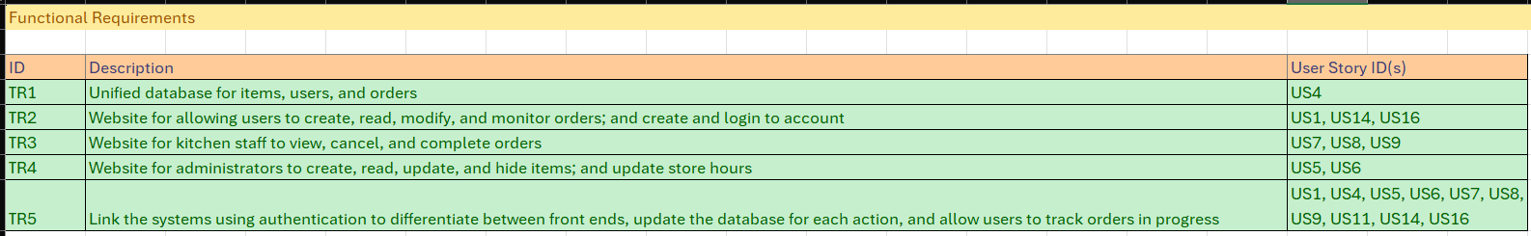
Technical Requirements
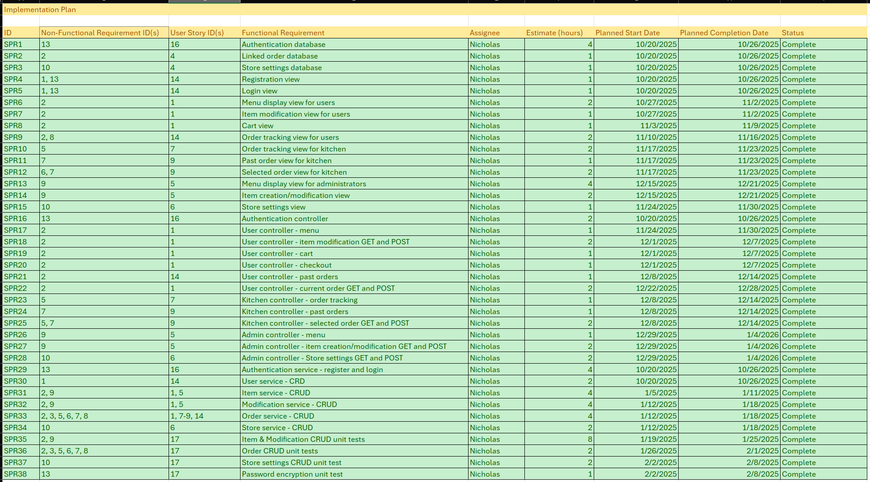
Development Plan – Progress at 100%

Test Plan, Test Cases, and Results

Item and Modification CRUD Test
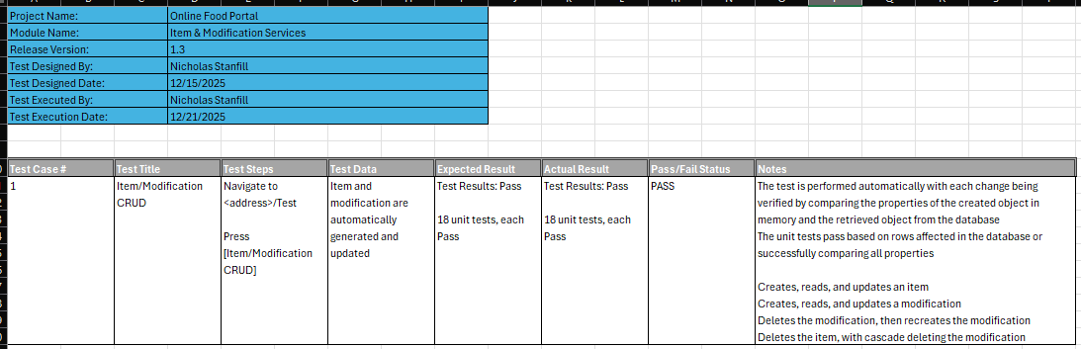
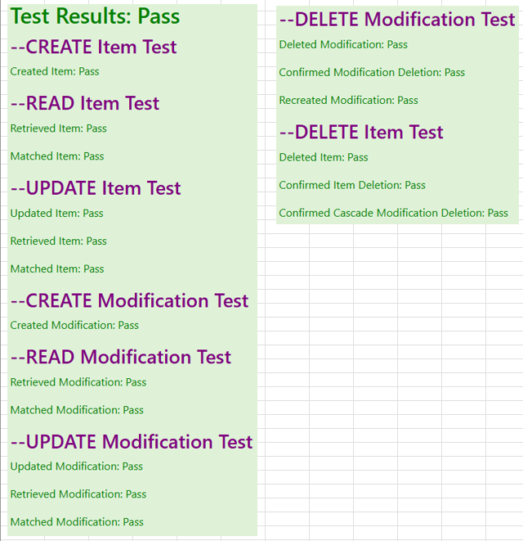

Order CRUD Test
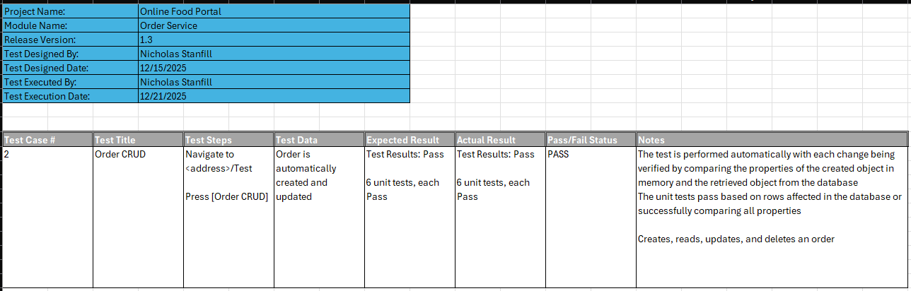
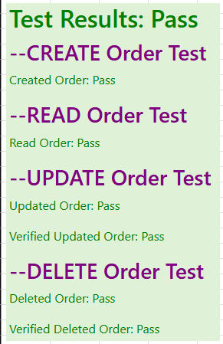

Password Hashing Service Test
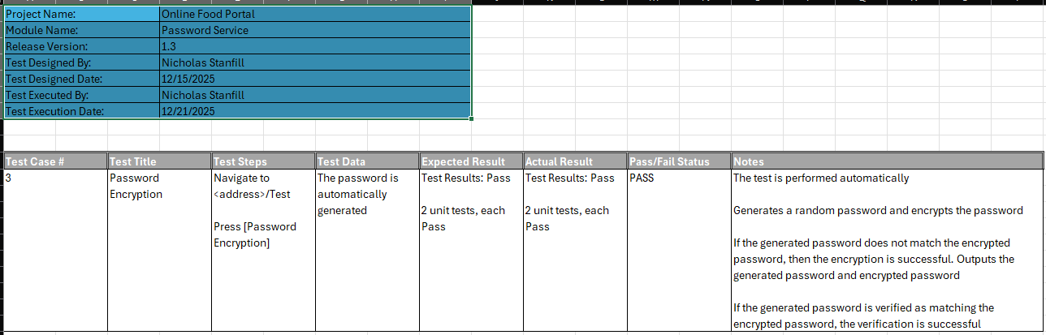
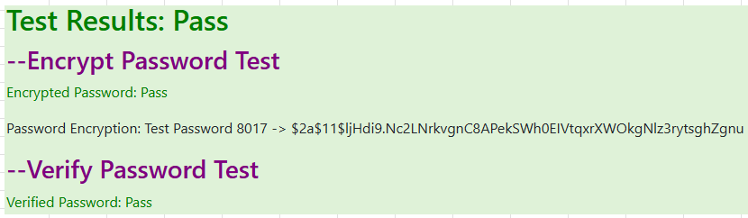

Store Settings RU Test
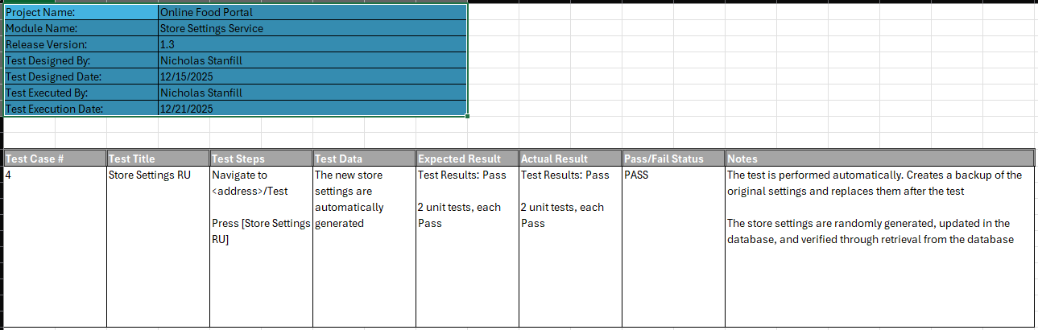
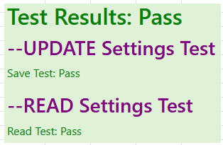

User CRD Test
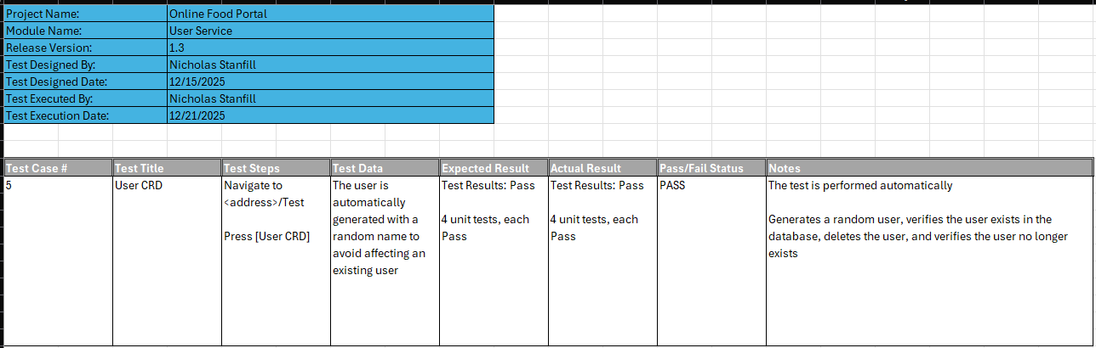
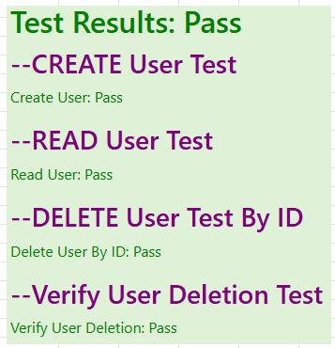

User Registration and Login Test
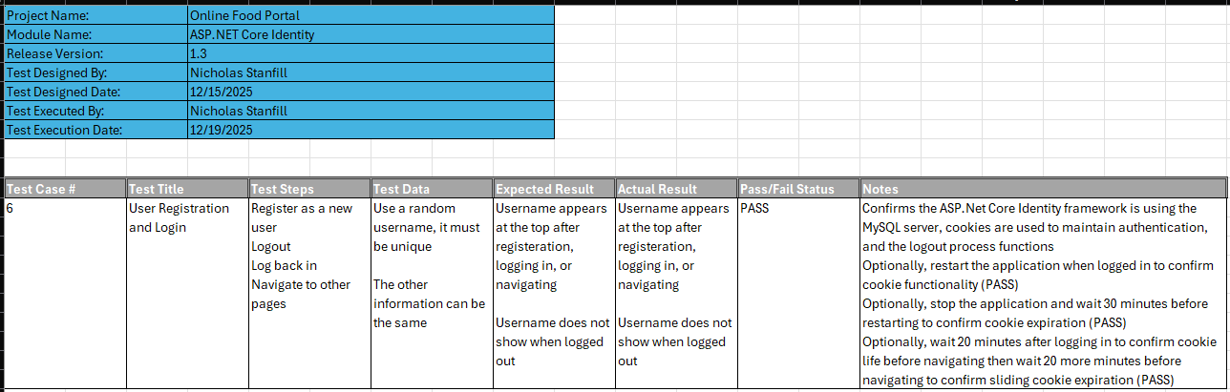
Test is performed manually, all results are PASS

